Butterfly Tracking System (BTS)

Use Case Specification Document

UC-05
Administration
Version No. 1.2

Project Document Revision History
VersionNumber | Date | Revision Author | Description of Revision
1.0 | 11/16/2015 | Yue Dai | Initial Creation
1.1 | 11/19/2015 | Yue Dai | Add flow and swimlane diagram for updating all records, deleting records
1.2 | 11/22/2015 | Yue Dai | Modify alternate flow

Table of Contents
1. Introduction 4
2. Use Case Information 4
2.1 Actors 4
2.2 Use Case Interaction 4
3. Trigger 5
4. Pre-condition(s) 5
5. Post-condition(s) 5
6. Use Case Swimlane (Activity) Diagram 6
6.1 Swimlane Diagram for updating existed account 6
6.2 Swimlane Diagram for creating new account 7
6.3 Swimlane Diagram for deleting existed account 8
7. Main/Basic Flow(s) of Events (Happy Path) 10
7.1 Update Existing Account: 10
7.2 Create New Account: 11
7.3 Delete Existing Account 11
7.4 Update all records 11
7.5 Delete records 12
8. Alternate/Exception Flow of Events 12
8.1 No existed account matching the criteria 12
8.2 Email address already exist 12
8.3 Criteria invalid 13
9. Assumptions/Business Rules including Non-Functional Requirements 13
10. Use Case Specification Review and Signoff 13

Introduction
The purpose of this use case is to let the administrator manage the account of other users which include other administrators and taggers/sighters and manage all the records inside this system. The functionalities are categorized into either functional or non-functional requirement. The functional ones listed are as follows:
- Administrator create new account for other users(administrators and taggers/sighters)
- Administrator update existed account of other users(administrators and taggers/sighters)
- Administrator delete existed account of other users(administrators and taggers/sighters)
- Administrator update all the records inside the system(butterfly, sighting)
- Administrator delete records inside the system(butterfly, sighting)
Our system is a web-based project. The user interface is to be function accurately on all platforms, including desktop computers, notebooks, and mobile devices.

Use Case Information

Actors
Actor Name | Role | Description
Administrator | Main | Users who manage the whole system

Use Case Interaction
Predecessor | UC-2 Session Management
Successor | None

Trigger

Functionality | Trigger
Administrator create new account | Create button pressed by the administrator after inputting the criteria (e.g. email address, password, street, and state, etc.).
Administrator update existed account | Update button pressed by the administrator after changing the criteria (e.g. email address, password, street, and state, etc.).
Administrator delete existed account | Delete button pressed by the administrator after inputting the criteria – email address.
Administrator update all the records inside the system | Update button pressed by the administrator after changing the criteria of records (e.g. location, state, tagger ID, sighter ID, etc.).
Administrator delete records inside the system | Delete button pressed by the administrator after inputting the criteria of records (e.g. Butterfly ID/Sighting ID).

Pre-condition(s)
Administrator is required to login before entering the management operation interface.

Post-condition(s)
The system will show a new window that will either contain a table or a simple message for the administrator view. The following determine the post condition of this use case:
    - Display a table to the administrator containing all the data of the account that has just been updated.
    - Display a table to the administrator containing all the date of the record that has just been updated.
    - Display a notification to show the result of the operation.

Use Case Swimlane (Activity) Diagram

Swimlane Diagram for updating existed account
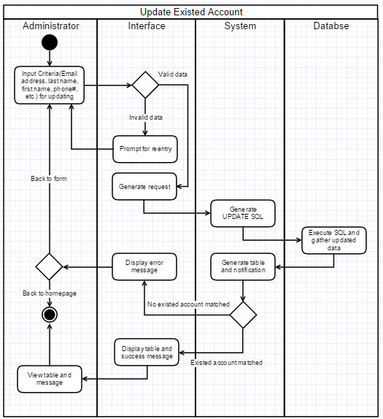
Diagram 6.1 Version 1.0 11/17/2015

Swimlane Diagram for creating new account
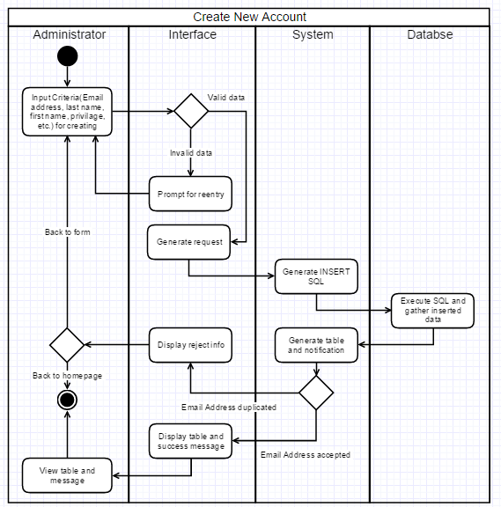
Diagram 6.2 Version 1.1 11/19/2015

Swimlane Diagram for deleting existed account
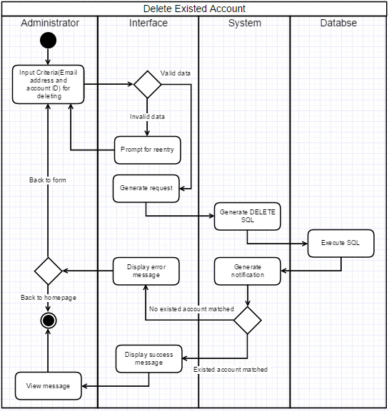
Diagram 6.3 Version 1.0 11/17/2015
  - Swimlane Diagram for updating all records.
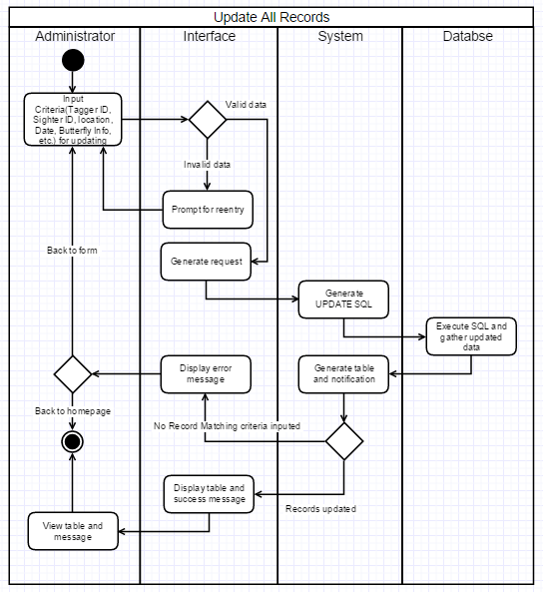
Diagram 6.4 Version 1.0 11/19/2015
  - Swimlane Diagram for deleting records
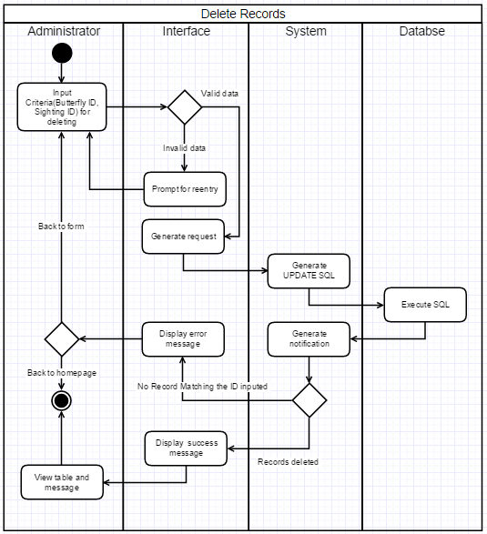
Diagram 6.5 Version 1.0 11/19/2015

Main/Basic Flow(s) of Events (Happy Path)

Update Existing Account:
      - The administrator will input criteria(Email address, last name, first name, etc.) for the existed account
      - The interface will check for invalid criteria
      - The system will generate UPDATE SQL and send it to the database
      - The database will execute the SQLand send result back to the system
      - The system will generate the report or table
      - The administrator will view the report/table

Create New Account:
      - The administrator will input criteria (Email address, last name, first name, etc.) for the new account
      - The interface will check for invalid criteria
      - The system will generate INSERT SQL and send it to the database
      - The database will execute the SQL and send result back to the system
      - The system will generate the report or table
      - The administrator will view the report/table

Delete Existing Account
      - The administrator will input criteria (Email address and account ID) for the existed account
      - The interface will check for invalid criteria
      - The system will generate DELETE SQL and send it to the database
      - The database will execute the SQL and send result back to the system
      - The system will generate notification
      - The administrator will view the notification

Update all records
      - The administrator will input criteria (Tagger ID, sighter ID, butterfly ID, location, date, etc.) for the existed records inside the system
      - The interface will check for invalid criteria
      - The system will generate UPDATE SQL and send it to the database
      - The database will execute the SQL and send result back to the system
      - The system will generate table and notification and send to the interface
      - The administrator will view the table contained updated information and notification

Delete records
      - The administrator will input Butterfly ID or Sighting ID for the existed records inside the system
      - The interface will check for invalid criteria
      - The system will generate DELETE SQL and send it to the database
      - The database will execute the SQL and send result back to the system
      - The system will generate the notification and send it to the interface
      - The administrator will view the notification

Alternate/Exception Flow of Events

No existed account matching the criteria
This alternate flow refers to diagram 6.1 and diagram 6.2
      - The administrator will input criteria for deleting or updating existed account
      - The interface will check for invalid criteria
      - The system will delete or update the record matching the criteria from the database
      - The system will notify the users that there is no existed account matching the criteria
      - The administrator view the notification

Email address already exist
This alternate flow refers to diagram 6.2
      - The administrator will input email address for creating a new account for other user
      - The interface will check for invalid criteria
      - The system will generate an INSERT SQL and send it to database
      - The database will send back rejection message
      - The system will send error message
      - The administrator will view the error message and input a new email address again

Criteria invalid
This alternate flow refers to all the diagrams in part 6
      - The administrator will input criteria to manage accounts or records inside the system
      - The interface will check for valid data.
      - The interface will display appropriate invalid data and prompt for reentry
      - The administrator will input criteria again

Assumptions/Business Rules including Non-Functional Requirements
The browsers that are used to access to the system are modern and capable of properly displaying the reports generated by the system.
Since the administrator is the one who can manage all the accounts, we assume that administrator should be the supervisor or manager of this project or the apartment.

Use Case Specification Review and Signoff
Review and Signoff of the Use Case Specification
Name | Project Team Role | Signature | Date
Issam Jassim | Team Leader | Ikj | 11/24/2015
Yue Dai | Front-end Developer | yd | 11/24/2015
Xiuyan Xin | Front-end Developer | xx | 11/24/2015
Nesrin Mohammed | Database Manager | nm | 11/24/2015

